**Model Development Phase Template**

|  |  |
| --- | --- |
| Date | 8 July 2024 |
| Team ID | 739677 |
| Project Title | FetalAI: Using Machine Learning To Predict And Monitor Fetal Health |
| Maximum Marks | 4 Marks |

**Initial Model Training Code, Model Validation and Evaluation Report**

The initial model training code will be showcased in the future through a screenshot. The model validation and evaluation report will include classification reports, accuracy, and confusion matrices for multiple models, presented through respective screenshots.

**Initial Model Training Code:**

**Random Forest:**

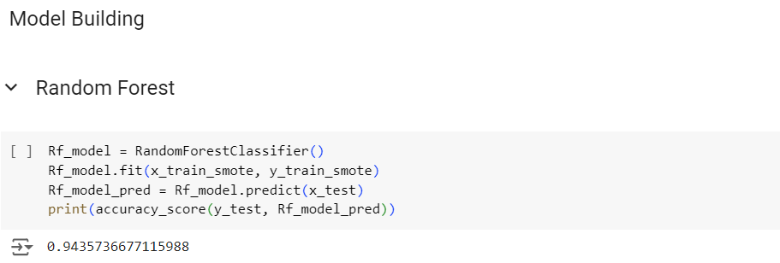

**Decision Tree:**

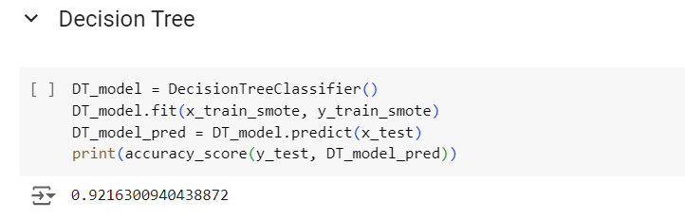

**Logistic Regression:**

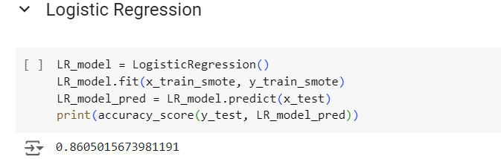

**K- Nearest Neighbors:**

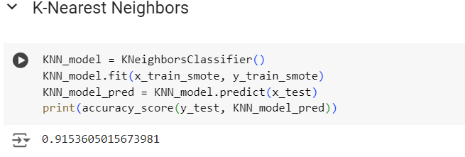**­­­­­**

**Model Validation and Evaluation Report:**

|  |  |  |  |
| --- | --- | --- | --- |
| **Model** | **Classification Report** | **Accuracy** | **Confusion Matrix** |
| Random Forest |  | 94% |  |
| Decision Tree |  | 92% |  |
| Logistic Regression |  | 86% |  |
| K -Nearest Neighbors |  | 91.5­­­­­% |  |